Last name: ______________________________ First name: _______________________________
Aboubeker Belkaid University –Tlemcen- year: March 2021
Class: Master 1
Teacher :Mrs BENAIS Time: 1 hour
Correction ofExamination of English

- Read the text carefully then do the activities below:
My daily routine
Hello,
I am James and I always get up at 7 o’clock to get ready for school. I wash my face, brush my teeth and brush my hair and put on my coolest clothes. Then I have breakfast with my family. I like cereal with some fruit and yoghurt. My sister prefers milk and toast with jam. We leave for school together at 8 o’clock by bus.

Today is Tuesday and my lessons start at 8:30 a.m. I have Maths, English and History in the morning. At midday I have lunch in the canteen. In the afternoon I don’t have lessons, so I stay with my friends. We do our homework and then we play football or basketball. Sometimes we ride our bikes or we go to the park and do some skateboarding. I love being with my friends.

I go home around 4 o’clock. I have something to eat, I play with my pets or I play a game. Then, before dinner, I have a shower and help my mother. We have dinner at 8 o’clock. After dinner we watch TV or play games together. I usually go to bed at 10:30 p.m.
Sam

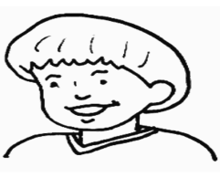

- Are these sentences about James True (T) or False (F)?
a) James prefers milk to cereals. False 0.5pt
b) Amy has cereal for breakfast.False 0.5pt
c) They go to school by bus.True0.5 pt
d) On Tuesdays he has Maths in the afternoon.False0.5pt
e) James and his friends play football in the afternoon.True
0.5pt
- Answer the following questions according to the text:
a) What time does James get up every morning?
He gets up at seven o clock 1pt.
b) What does his sister have for breakfast?
His sister has milk and toast with jam for breakfast 1pt
c) Does James have lunch at home?
No he does not 1pt
d) Who does he stay with in the afternoon?
He stays with his friends 1pt
e) When does James take a shower?
He takes shower before dinner 1pt
- What or who do the underlined words in the text refer to?
- My →…James 0.25pt…………….. b. we →James and his friends 0.25pt………………..
- Find in the text synonyms to:
- likes (§1) = prefers 0.25pt………………. b. begin (§2) = start 0.25pt………………. c. sleep (§3) =go to bed 0.25pt……………….
- Find in the text opposites to:
- warmest (§1) coolest…0.25pt……………. b. stay (§1) leave0.25pt………………. c. alone (§3) together 0.25pt……………….
- Choose the correct tense form:
- Maria _has0.25pt_______ two sisters. a) have b) has c) is
- My dog Snoopy ________ near the garage. a) sleep b) sleeps0.25 c) am sleeping
- This town ________ a Shopping Centre. a) haven’t got b) have not c) doesn’t have0.25
- ________ your name Michael? a) Are b) Is 0.25 c) Aren’t
- The Browns ________ in a new house. a) lives b) doesn’t live c) live0.25
- Last night, I (to see) __________a wonderful match. a) Sees b) seed c) saw

- Ask questions for the following answers.
- My name is Robert.
- What is your name?0.5pt
- I’m 14 years old.
- How old are you ?0.5pt
- I live in London.
- Where do you live ?0.5pt
- No, I’m from Ireland.
- Are you from Scotland?0.5pt
- Yes, I have got one brother and three sisters.
- Do you have got sisters and brothers?0.5pt
- My favourite book is Harry Potter and the Order of the Phoenix.
- What is your favourite book ?0.5pt

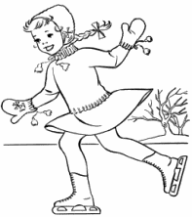
- Look at the pictures and write what they are doing right now.
Use: is/are + stem +ing

a) Sarah is skating on ice 0.5pt_
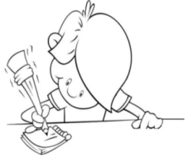

b) Nadia is writing0.5pt___________________________________

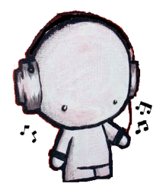
c) Tom is playing music0.5pt

d) Farid is listening to music 0.5pt

9. Now write a short paragraph about what you do every Saturday. Do not forget to mention:

● Time you get up
● Two things you do in the morning
● Two activities with your friends in the afternoon
● Some indoor activities with your family at night

____________coherence 2.5pt_________________________________________________________________________________________cohesion 2.5pt__________________________________________________________________________________________________________________________________________________________________________________________________________________________________________________________________________________________________________________________________________________________________________________________________________________

Good Luck

